*This member is currently a Probationary member of the Stunt Guild Ireland. The member can only be contacted through a Stunt Guild Ireland Coordinator or the email address below:* [*stuntguildireland@yahoo.com*](mailto:stuntguildireland@yahoo.com)

IMDB: [*https://www.imdb.me/jordancoombes*](https://www.imdb.me/jordancoombes)

Probationary Stunt Performer

Jordan Coombes

***Measurements:***

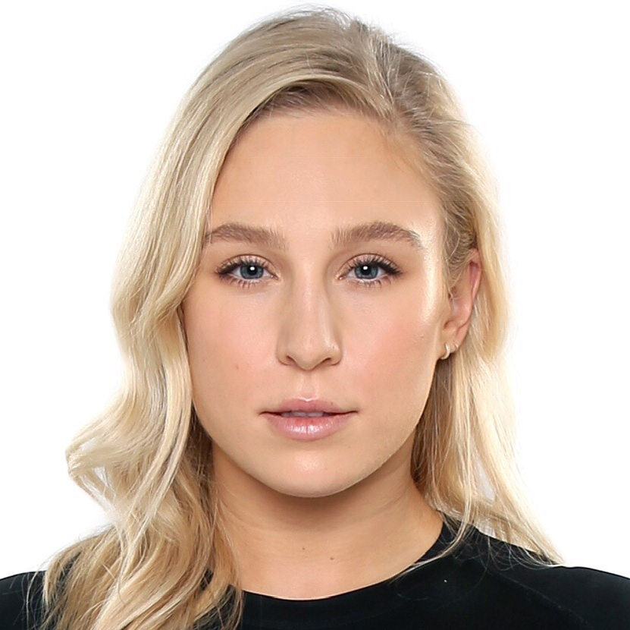

Height: 162cm  
Waist: 70cm

Chest: 98cm

Neck: 33cm

Shoe Size: 5.5UK

Hair Colour / Length: Blond/Long  
Eye Colour: Blue

**Sample of Credits**

**FF** *Disenchanted* – Stunt Double (Giselle/Amy Adams), Stunt Rigger

**FF** *Northman* – Stunt Performer

**TV***Foundation* – Stunt Rigger, Stunt Double (Shivaghan)

**TV** *Fate: The Winx Saga* - Stunt Performer

**TV** *The Decieved*– Stunt Double (Emily Reid)

**TV** *Vikings**– Season 2-6* – Stunt Double (Katherine Winnick)

**FF** *Greta*– Stunt Double (Chloë Grace Moretz)

**FF** *Accident Man*– Stunt Double (Amy Johnson)

**TV** *Into the Badlands - Season 2 & 3* - Stunt Performer

**TV** *Penny Dreadful – Season 1 –* Stunt Performer

Full List of Credits Available on IMDB

**On Set Experience**

Lead Actor Doubling

Horse Riding/ Saddle Falls

Stunt Fighting / Actor fights (Unarmed, Sword & Shield, Knife)

Falls/ Break away Furniture

Water Safety, Fire Safety

Performing on Wires (jerk backs, fly rigs, hangings, etc.)

**Additional Information**

PADI Divemaster

HSE Commercial Diver

Rock Climbing Instructor, Single Pitch Award – Mountaineering Ireland

Horse Riding Stunt Test Qualification

IRATA – Level 1 Rope access technician

IDCA Certified in Broadsword, Sword & Shield, Rapier & Dagger, Unarmed Combat, Knife

Firearms and Tactical Training – EuroTactical

Gaiety School of Acting Graduate – 2 year Full time Acting Training 2010-2012

Bow Street Academy – Full time Screen Acting Graduate 2014

Kickboxing – 5th Belt

Gymnastics experience